Assignment 1

**Q2An experimenter recorded a SINGLE cortical neuron’s activity from the part of the brain**

**processing visual information as the organism viewed a visual stimuli on the screen. The**

**collected dataset is attached herewith: ‘Data1_NDM.mat’. It is a Three-dimensional MATLAB**

**array. Note the following.**

**● Dimension 1 = Stimulus orientations (45 degree to 202.5 degree with increments in step**

**size of 22.5 degree visual angle).**

**● Dimension 2 = Time (sampling frequency of the neuronal activity = 1000 Hz); Total**

**neuronal recording duration = 3.5 seconds; Time = 0 (stimulus not moving);Time = 500**

**(stimulus moving) ; Time = 2500 (stimulus off);**

**● Dimension 3 = Trials or stimulus repetitions**

**● Value 1 = action potential (spike) fired by the neuron; Value 0 = no action potential fired**

**by the neuron**

**Now solve the following. Insert a figure (wherever required) and paste the MATLAB/Python/R**

**code for the same. Any figure must provide all information necessary to interpret it including**

**axes labels, captions/legends (see Fig.1 of the attached paper for a sample; simple figure titles**

**as captions are not enough).**

**[ links about the 3-dimensional array in MATLAB and importing MATLAB data arrays into**

**Python and R**

**• https://in.mathworks.com/help/matlab/math/multidimensional-arrays.html**

**• https://in.mathworks.com/help/matlab/matlab_external/matlab-arrays-as-python-variables.html**

**• https://stackoverflow.com/questions/11671883/importing-an-array-from-matlab-into-r ]**

**A. Create a Raster plot of the neuron for ALL EIGHT orientations of the stimulus and mark**

**the onset of stimulus movement and offset of the stimulus by a vertical green and red**

**line respectively on the same individual subplots. Mark the spikes (action potentials)**

**with solid black circles. [5 marks]**

**Hint: Create a larger figure with eight subplots (positioned as 4 rows x 2 columns);**

**Indicate the stimulus orientation on top of each subplot as subplot title**

**Code is:**

#!/usr/bin/env python

# coding: utf-8

# In[2]:

import scipy.io

import matplotlib.pyplot as plt

import numpy as np

# In[3]:

data = scipy.io.loadmat("Data1_NDM.mat")

data

# In[7]:

spikes = data['Data1_NDM']

# taking orientations

Orientations = spikes.shape[0]

OrentationDegree = [45,67.5,90,112.5,135,157.5,180,202.5]

# taking timepoints

TimePoints = spikes.shape[1]

# Taking trials

Trial = spikes.shape[2]

fig, axis = plt.subplots(4, 2, figsize=(20, 20))

for i in range(Orientations):

    dataS = spikes[i, :, :]

    xDimension = i //2

    yDimension = i%2

    # Now here we will plot raster plot

    iTrial = 0  # Initialize the trial index

    while iTrial < Trial:

        spike = [g for g in range(TimePoints) if dataS[g, iTrial] == 1]

        axis[xDimension, yDimension].plot(spike, [iTrial] * len(spike), 'ko', markersize=5)

        iTrial += 1

    # Mark the onset of stimulus movement

    axis[xDimension, yDimension].axvline(x=500, color='#00FF00', linestyle='--', label='Stimulus Onset')

    # Mark the offset of stimulus movement

    axis[xDimension, yDimension].axvline(x=2500, color='#FF0000', linestyle='--', label='Stimulus Offset')

    # #00FF00 - Green

    # #FF0000- Red

    # Setting  the title

    axis[xDimension, yDimension].set_title(f'Orientation : {OrentationDegree[i]} degrees')

    # Set the x-axis as  Time (m/s)

    # and y-axis as Trails labels

    axis[xDimension, yDimension].set_xlabel('Time (m/s)')

    axis[xDimension, yDimension].set_ylabel('Trial')

    axis[xDimension, yDimension].legend()

# Adjust subplot layout

plt.tight_layout()

# Show the plot

plt.show()

# In[ ]:

OutPut is:

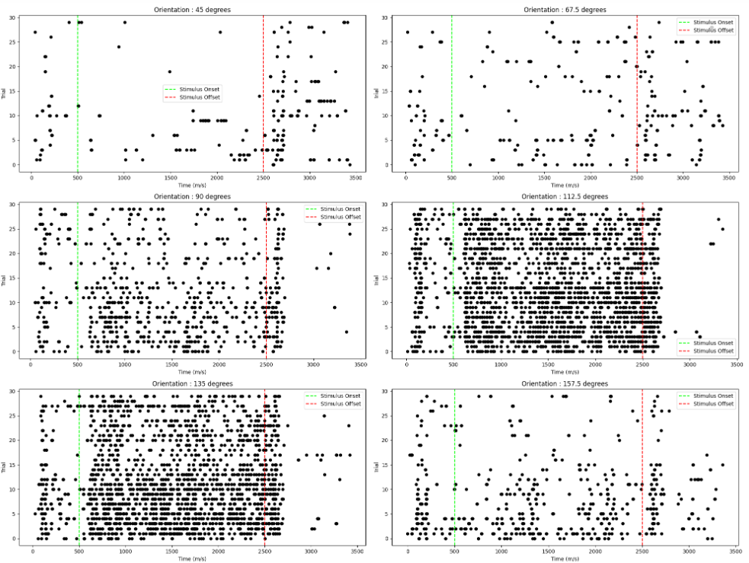

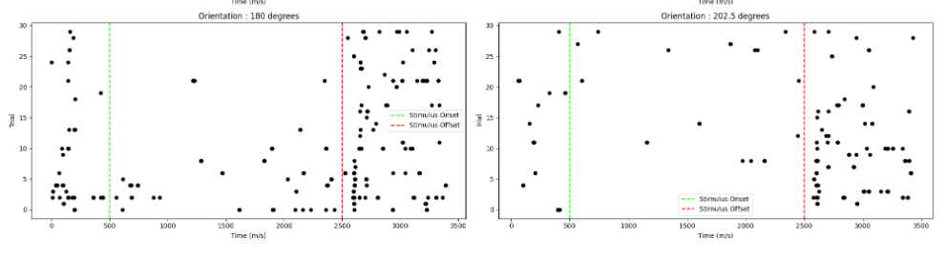

**B. Create a Peri Stimulus Time Plot of the neuron for ALL EIGHT orientations of the**

**stimulus and mark the onset of stimulus movement and offset of the stimulus by a**

**vertical green and red line respectively on the same individual subplots. Before**

**computing the histogram, smooth the data for each subplot over a time window of 61**

**ms. [5 marks]**

**Hint: Create a larger figure with eight subplots (positioned as 4 rows x 2 columns);**

**Smooth the data by moving average method; A line plot would suffice and depict the**

**trend; Indicate the stimulus orientation on top of each subplot as subplot title**

**Code is:**

#!/usr/bin/env python

# coding: utf-8

# In[1]:

import scipy.io

import numpy as np

import matplotlib.pyplot as plt

# In[2]:

data = scipy.io.loadmat("Data1_NDM.mat")

# In[3]:

OrentationDegree = [45,67.5,90,112.5,135,157.5,180,202.5]

TimeWindow = 61

fig, axis = plt.subplots(4, 2, figsize=(20, 20))

for i, axis in enumerate(axis.flat):

    orientation_data = data['Data1_NDM'][i][:][:]

    SmoothedData = np.convolve(orientation_data.mean(axis=1), np.ones(TimeWindow)/TimeWindow, mode='same')

    # Plot the smoothed data

    axis.plot(SmoothedData)

    axis.axvline(x=500, color='#00FF00')  # Onset of stimulus movement

    axis.axvline(x=2500, color='#FF0000')  # Offset of stimulus

    # #00FF00 - Green

    # #FF0000- Red

    axis.set_xlabel('Time (ms)')

    axis.set_ylabel('Trials')

    axis.set_title(f'Stimulus Orientation: {OrentationDegree[i]} degrees')

# Display the figure

plt.tight_layout()

plt.show()

# In[ ]:

**Output is:**

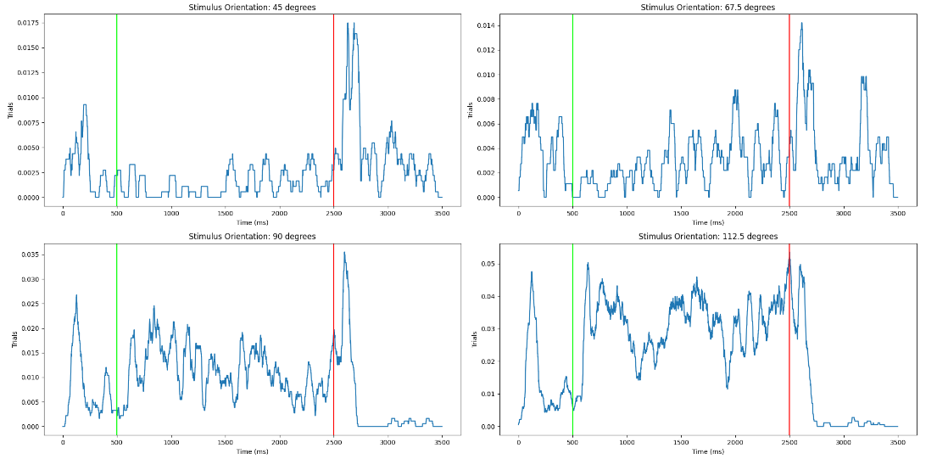

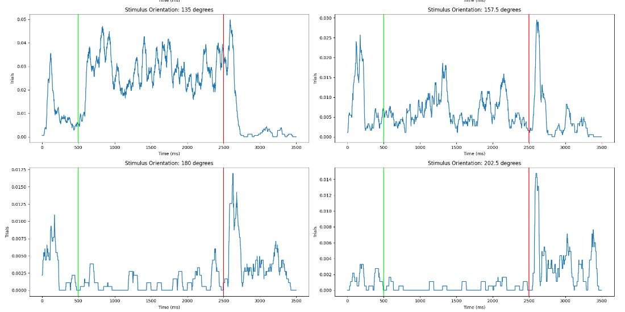

**C. Create a figure representing the Tuning Curve of the neuron from the average firing rate**

**of the neuron (between 600 – 2500 ms and all trials) for each orientation.**

**Computationally calculate the ‘preferred orientation’ of the neuron. Report the same on**

**the title of the plot and mark it on the plot. [5+5 marks]**

**A.**

**Code :**

data = sio.loadmat('Data1_NDM.mat')['Data1_NDM']

data

# In[6]:

#Q2c-1st Part

#  As given in the question we define the time window for analysis Start Time is 600 ms and EndTime is  2500 ms

StartTime = 600

EndTime = 2500

Orientations = data.shape[0]

NumTimePoints = data.shape[1]

# Stimulus orientations

OrentationDegree = [45,67.5,90,112.5,135,157.5,180,202.5]

NumTrials = data.shape[2]

FiringRates = np.zeros((Orientations, NumTrials))

i = 0

while i < NumTrials:

    orien = 0

    while orien < Orientations:

        spike = data[orien, :, i]

        # Calculate firing rate by counting spikes within the time window

        FiringRate = np.sum(spike[StartTime:EndTime]) / ((EndTime - StartTime) / 1000)

        # Storing firing rate

        FiringRates[orien, i] = FiringRate

        orien += 1

    i += 1

# Now calculating the mean firing rate across all trials for each orientation

mean_firing_rates = np.mean(FiringRates, axis=1)

plt.figure()

plt.bar(OrentationDegree, mean_firing_rates)

plt.plot(OrentationDegree, mean_firing_rates,'ko--')

plt.xlabel('Orientation (degrees)')

plt.ylabel('Mean Firing Rate (spikes/second)')

plt.title('Tuning Curve of the Neuron')

plt.show()

# In[13]:

**Output :**

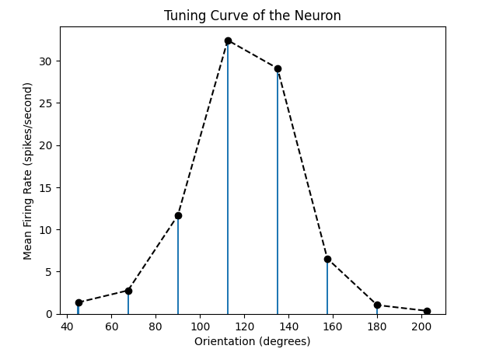

**B.**

**Code:**

#Q2c- 2nd Part

# Stimulus orientations

OrentationDegree = [45,67.5,90,112.5,135,157.5,180,202.5]

TimeWindow = range(600, 2500)

#  To store the average firing rates

AverageFiringRates = []

i = 0

while i < len(OrentationDegree):

    OrientationData = data[i, TimeWindow, :]

    # Now to calculate average firing rate for this orientation

    average_firing_rate = OrientationData.mean()

    AverageFiringRates.append(average_firing_rate)

    i += 1

# Now we calcute the preferred orientation

preferred_orientation = orientations[np.argmax(average_firing_rates)]

plt.figure(figsize=(10, 6))

# Ploting the tuning curve

plt.plot(OrentationDegree, AverageFiringRates, marker='o')

plt.axvline(x=preferred_orientation, color='#FF0000', linestyle='--')

# #FF0000- Red

plt.xlabel('Stimulus Orientation (degrees)')

plt.ylabel('Average Firing Rate')

plt.title(f'Tuning Curve of Neuron of the Preferred Orientation: {preferred_orientation} degrees)')

plt.show()

# In[ ]:

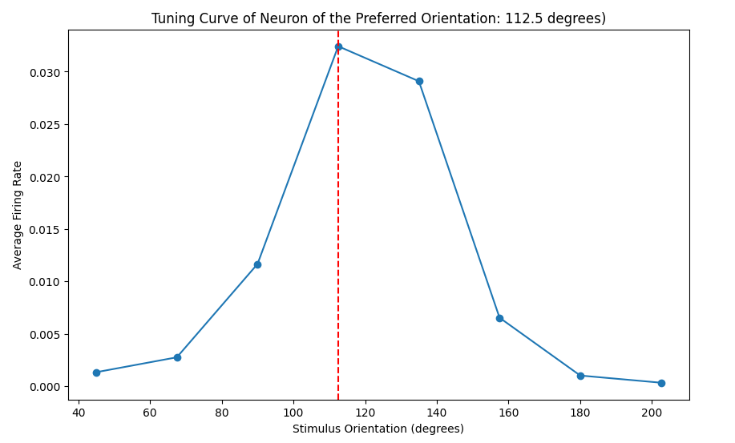

**Whole Code:**

#!/usr/bin/env python

# coding: utf-8

# In[4]:

import numpy as np

import scipy.io as sio

import matplotlib.pyplot as plt

# In[5]:

data = sio.loadmat('Data1_NDM.mat')['Data1_NDM']

data

# In[6]:

#Q2c-1st Part

#  As given in the question we define the time window for analysis Start Time is 600 ms and EndTime is  2500 ms

StartTime = 600

EndTime = 2500

Orientations = data.shape[0]

NumTimePoints = data.shape[1]

# Stimulus orientations

OrentationDegree = [45,67.5,90,112.5,135,157.5,180,202.5]

NumTrials = data.shape[2]

FiringRates = np.zeros((Orientations, NumTrials))

i = 0

while i < NumTrials:

    orien = 0

    while orien < Orientations:

        spike = data[orien, :, i]

        # Calculate firing rate by counting spikes within the time window

        FiringRate = np.sum(spike[StartTime:EndTime]) / ((EndTime - StartTime) / 1000)

        # Storing firing rate

        FiringRates[orien, i] = FiringRate

        orien += 1

    i += 1

# Now calculating the mean firing rate across all trials for each orientation

mean_firing_rates = np.mean(FiringRates, axis=1)

plt.figure()

plt.bar(OrentationDegree, mean_firing_rates)

plt.plot(OrentationDegree, mean_firing_rates,'ko--')

plt.xlabel('Orientation (degrees)')

plt.ylabel('Mean Firing Rate (spikes/second)')

plt.title('Tuning Curve of the Neuron')

plt.show()

# In[13]:

#Q2c- 2nd Part

# Stimulus orientations

OrentationDegree = [45,67.5,90,112.5,135,157.5,180,202.5]

TimeWindow = range(600, 2500)

#  To store the average firing rates

AverageFiringRates = []

i = 0

while i < len(OrentationDegree):

    OrientationData = data[i, TimeWindow, :]

    # Now to calculate average firing rate for this orientation

    average_firing_rate = OrientationData.mean()

    AverageFiringRates.append(average_firing_rate)

    i += 1

# Now we calcute the preferred orientation

preferred_orientation = orientations[np.argmax(average_firing_rates)]

plt.figure(figsize=(10, 6))

# Ploting the tuning curve

plt.plot(OrentationDegree, AverageFiringRates, marker='o')

plt.axvline(x=preferred_orientation, color='#FF0000', linestyle='--')

# #FF0000- Red

plt.xlabel('Stimulus Orientation (degrees)')

plt.ylabel('Average Firing Rate')

plt.title(f'Tuning Curve of Neuron of the Preferred Orientation: {preferred_orientation} degrees)')

plt.show()

# In[ ]: